**IMAT3451 Project Contract Template – Development Projects**

**Student Name-Mohit Gautam**

**P-number-P15194912**

**Programme-Computer science**

**Email address-Mohitgautam256@hotmail.com**

**Project Title – Restaurant Table Reservation Android App.**

**Project Proposer**

The name, affiliation and contact details of the project proposer - your name if it was proposed by you.

*Mr Mohit Gautam, DMU Computer science Student.*

**Supervisor**

Dr Richard Bates, Lecturer, School of Computing, [Richard.Bates@dmu.ac.uk](mailto:Richard.Bates@dmu.ac.uk)

**Introduction**

The project I am going to develop is going to be an android app which is going to be an restaurant reservation booking app. In this contract I will talk about all the features that I will include on my app and I will also talk about what the aims/deliverables of my app will be.

**Project Background**

My app idea comes from my interest towards developing new things and i always was a very interested person in programming. The interest also came from my family business restaurant, where sometimes restaurant had difficulties to manage tables and allocate the bookings in certain times for the customers. Because of finding it hard to manage bookings on a busy night due to people just ringing up and saying “Could I book a table please?” and the staffs their just tend to say “yes” to all the bookings which caused many double booking and other problem. So I think developing this app would not just help my family run restaurant, in fact it could help all the other restaurants that are out there who are finding it hard to manage the tables for their customers.

The reason I am captivated about android is on the grounds that a large portion of the hands on innovation working frameworks are android based, and I figure it will be an awesome open door for me in future also on the off chance that I figure out how to create android application.

**Aim/Objectives/Deliverables**

**Aims**:

The aim of the project is that it will develop a restaurant table booking app for android devices. The app will be beneficial for both of the users (restaurant owner and the app user) this is because the app will allow users to choose the table they prefer so they can sit at their choice of the table, and on the other hand the restaurant owner won’t have to manage the tables or worry about having a double bookings as the app will do it itself automatically and only show the available tables. For this procedure to work, I will also have to develop an another app which will be used from restaurant, and through that application they can manage/update basic information by themselves such as changing the tables layout or updating pictures etc.

How would I do it?

**Objectives**: a list of specific, measurable objectives, each of which is likely to result in a deliverable. They specify all the work tasks to be undertaken to meet the stated aim. They will vary from project to project, as every project is different, but some examples are provided below.

All projects will need to review and report on the literature in a chosen area.

Software Development projects might include such general objectives as:

* To investigate system requirements and produce a Requirements Specification.
* To research and write a report on good practice in HCI design.
* To design an interface using the findings from the HCI report.
* To design and execute a suitable test plan.

Or they might be more specific, e.g.:

* To review and report on how mathematical simulation techniques could be applied to a

traffic simulator.

There are several objectives that needs be completed for this project to be successfully developed. The list of objectives are provided below:

1) To finalise my project and sign-off a project contract, ethical review, BCS check-list and Ethical check-list for my project by week 4.

2) To conduct a literature review the current restaurant booking systems techniques, and to examine and summarise the current application and checking how were they developed and what software were used, investigate the ways to connect the application to the users and the restaurant owners.

3) To produce a list of hardware and software requirements for the development of my project.

4) To produce a first submission report by end of week 7 that includes the contract, literature review, and requirements specification.

5) To design my project software using class diagrams, entity relationship diagrams, storyboards and interface designs and other appropriate tools.

6) To find a way of which will link between the customer apps and the restaurant control app, connecting the many customer apps to the single restaurant app.

7) To test my software and identify problems, document those problems, and attempt to solve those problems.

8) To produce a final report and critical evaluation of my work, with appendices detailing code and design highlights.

**Deliverables:** a list of your Project’s deliverables with some general description.

**First Report**

Week 7

***The Deliverable will contain:***

* + - * **Project contract**

Project contract will contain all the information about how I am going to develop the project, what will I include in the project and how will I complete it.

* + - * **Ethics form**

Ethical form will contain whether if there will be any ethical issues while developing my application

* + - * **Project Plan (e.g., Gantt Chart)**

Project plan will contain my actual plan for the project itself. I will complete this plan by creating a Gantt chart.

* + - * Global Check-list

To check whether if my project would have global impact, will my project be specifically targeted for only one restaurant or many?

* + - * Literature Review
      * Requirements Specification *detailing the things my app will do.*

**Final Report**

Week 29

***The Deliverable will contain:***

* + - * Use Case Diagrams/Use Case Descriptions/Class diagrams/ER model/State transition diagrams *of my app*
      * Story boards/Interface Designs *and life-cycle of the project*
      * Design Documentation
      * Test Plan *and test results, verification and validation of the work*
      * Prototype
      * Final report, including critical evaluation *and future work*
      * Software
      * Appendices (e.g. further design documentation, test logs)
      * **Main report maximum word count (main body): 15.000**
      * **Unlimited Appendices – be sensible here!**

**Viva examination**

**W**eeks 30-32

* + - * Oral examination, powerpoint and demo of your app.
      * Attended by the supervisor and the 2nd marker
      * (During week 28 supervisors and students will need to arrange setting up the Viva)

**Resources and Constraints**

For the application that I will be developing, I will require an access to an android developer studio installed on my laptop. I would also need at least android device with me.

I would also need to know information about the restaurant on how the owner wants the app to be. I would need access to the all the inside view of the restaurant and pictures of each tables to ensure that restaurant could choose the table that they like.

**Sources of Information**

To complete this application, I will be using a lot of sources of information. First I will have to talk to the restaurant owners and gather some basic information about the restaurant such as e.g. opening times and closing times etc.

Furthermore, to find out about different views and perspective of people towards the application that I will be developing, I will conduct a survey where it would be an anonymous , and I will use this survey as a source of useful information to talk about whether other restaurant will think if the app would be effective or not for their business.

To gain my knowledge for developing android I will be looking at tutorials videos on YouTube on how to develop the application.

**Risk Analysis**

What could endanger your project, what will you do if it happens

During the process to develop the app, there might me some risk which needs to be analysed before starting my project. The risk that I could be facing throughout my project can be such things as:

* Loss of work
* Not attending the meetings
* Not following up the plan (Gantt chart)
* Personal issues/illness

However to prevent all of these from happening I will have to take an action towards those risk and make sure they don’t happen. To do this I will make sure I will have an alternative backup plan to get the work back. To prevent any loss I will use GIThub to store and organise my project files.

I will also try my best to attend all of the meetings assigned by my supervisor. If somehow I am unable to turn up to the meeting, I will rearrange another suitable time for a meeting with my supervisor.

Another issue as I have mentioned above on the list is one of the main issue that could occur several times throughout developing my app, which is not following up the plan. This issue could prevent my project from completing it, within the deadline period time. So for me to prevent from this issue, I will monitor my progress and take notes and ensure that I hit my planned targets on time, I will also have to make sure that I am confident on what I’m doing, asking for help with supervisor if I’m faced with my any sort of problem with my report. And I will also ensure i keep good time management.

**Schedule of Activities**

Having defined the tasks to be undertaken in the list of objectives, you need to prepare a Project Plan to show how you intend to carry them out: You may find it helpful to draw up a critical path diagram before drawing a Gantt chart.

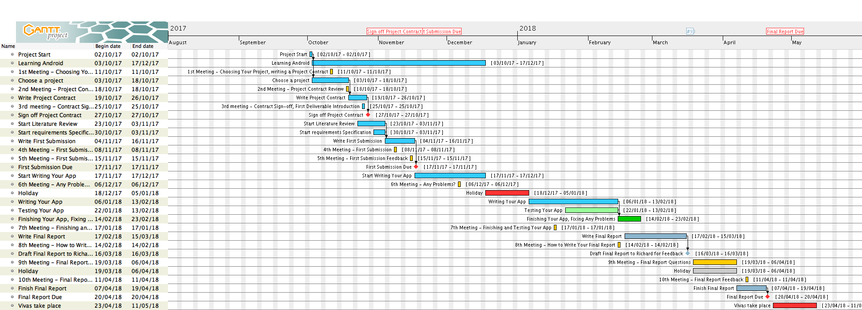

**Student__________________________________ Date_______________**

**Proposer ________________________________ Date_______________**

**Supervisor_______________________________ Date_______________**

Keep the signed copy somewhere safe: include it with your initial submission. Your supervisor will require a copy as well.

*That’s it!*